Vertex in Solid Geometry
# Source: AI Source: Provided by: [Data Path: Persons Table -> ID Column: 1, Name_En Column: Motasem Essam] -> From: [ChatGPT] on [7/25/2026]
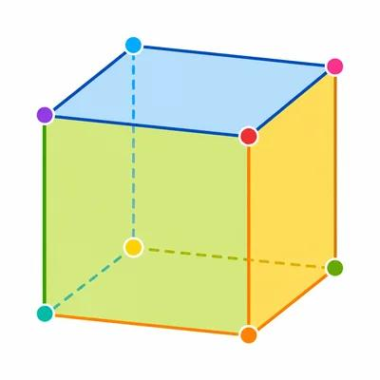
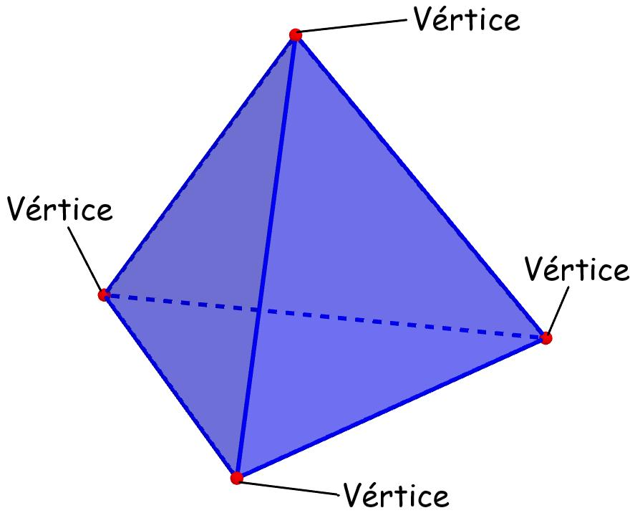
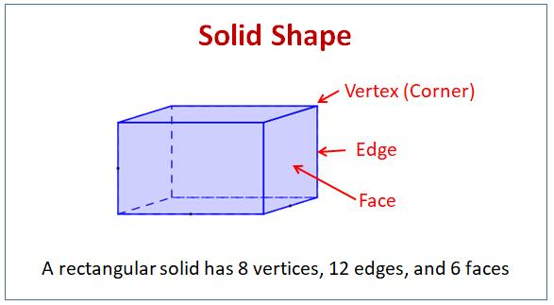

Definition
# Source: AI Source: Provided by: [Data Path: Persons Table -> ID Column: 1, Name_En Column: Motasem Essam] -> From: [ChatGPT] on [7/25/2026]
A vertex (plural: vertices) is a point where two or more edges, line segments, or boundary elements of a geometric solid meet. In a polyhedron, a vertex is a corner where three or more edges meet.
Vertices help define the shape, structure, and boundaries of three-dimensional geometric objects.

Simple Definition
# Source: AI Source: Provided by: [Data Path: Persons Table -> ID Column: 1, Name_En Column: Motasem Essam] -> From: [ChatGPT] on [7/25/2026]
A vertex is a corner point of a solid where its edges meet.
For example, a cube has 8 vertices, one at each corner.

Key Characteristics
# Source: AI Source: Provided by: [Data Path: Persons Table -> ID Column: 1, Name_En Column: Motasem Essam] -> From: [ChatGPT] on [7/25/2026]
- Zero-dimensional: A vertex is a point and has no length, area, or volume.
- Corner location: It identifies a corner of a solid, especially a polyhedron.
- Edge connection: Edges meet at vertices.
- Face connection: In a polyhedron, the boundaries of adjacent faces meet around vertices.
- Countable: The number of vertices can be determined for many standard solids.
- Position: A vertex can be represented by three-dimensional coordinates \((x,y,z)\).

Vertices in Different Solids

Cube
# Source: AI Source: Provided by: [Data Path: Persons Table -> ID Column: 1, Name_En Column: Motasem Essam] -> From: [ChatGPT] on [7/25/2026]
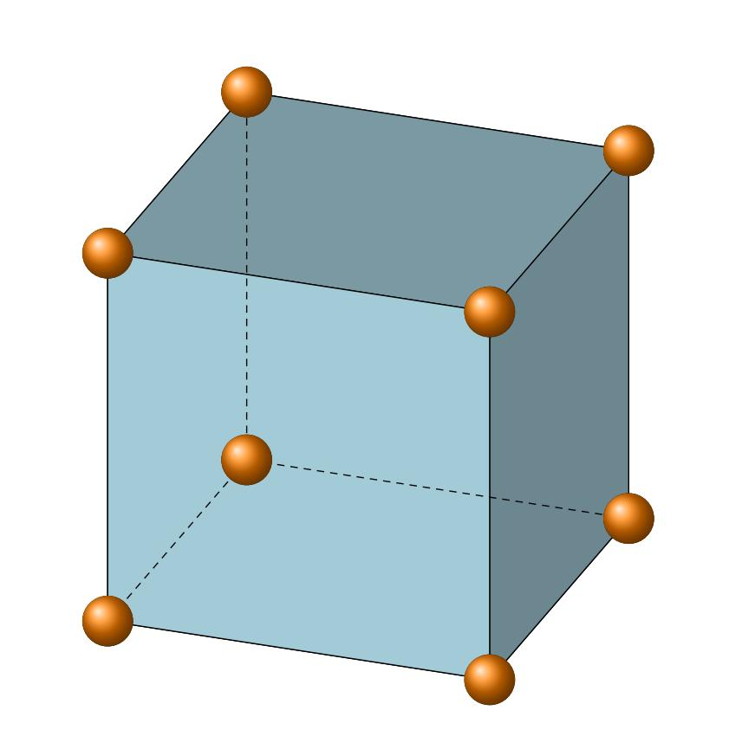
- Vertices: 8
- Each vertex connects 3 edges.
- Example: a corner of a dice.

Cuboid (Rectangular Prism)
# Source: AI Source: Provided by: [Data Path: Persons Table -> ID Column: 1, Name_En Column: Motasem Essam] -> From: [ChatGPT] on [7/25/2026]
- Vertices: 8
- Each vertex connects 3 edges.
- Example: a rectangular box.
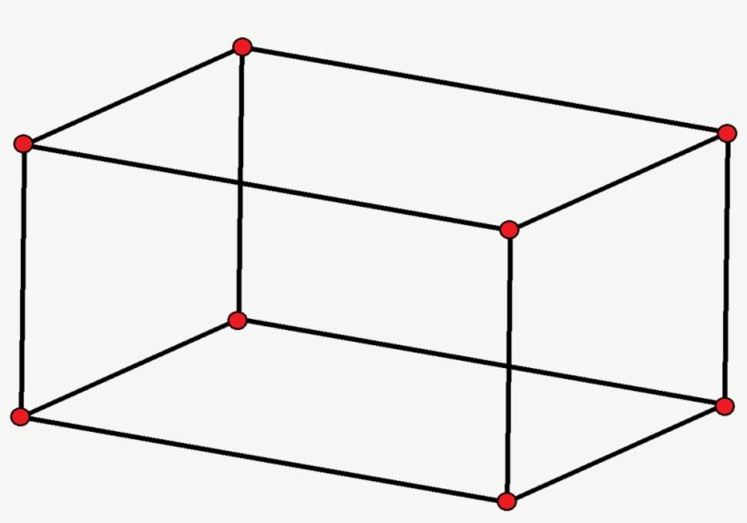

Square Pyramid
# Source: AI Source: Provided by: [Data Path: Persons Table -> ID Column: 1, Name_En Column: Motasem Essam] -> From: [ChatGPT] on [7/25/2026]
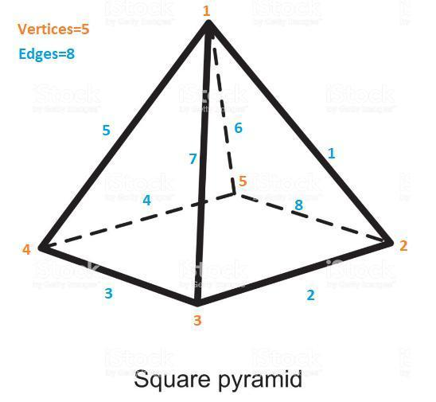
- Vertices: 5
- Four vertices form the base; one is the apex.
- The apex connects to the base vertices through edges.

Triangular Prism
# Source: AI Source: Provided by: [Data Path: Persons Table -> ID Column: 1, Name_En Column: Motasem Essam] -> From: [ChatGPT] on [7/25/2026]
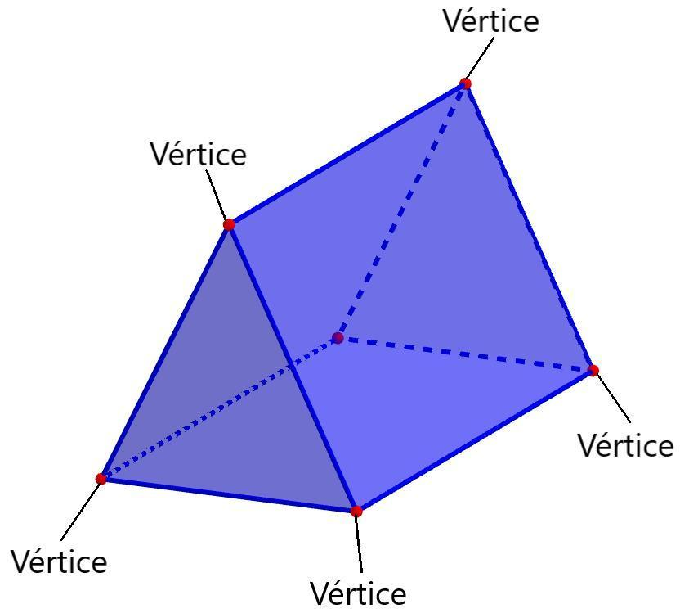
- Vertices: 6
- Two triangular bases have 3 vertices each.

Sphere
# Source: AI Source: Provided by: [Data Path: Persons Table -> ID Column: 1, Name_En Column: Motasem Essam] -> From: [ChatGPT] on [7/25/2026]
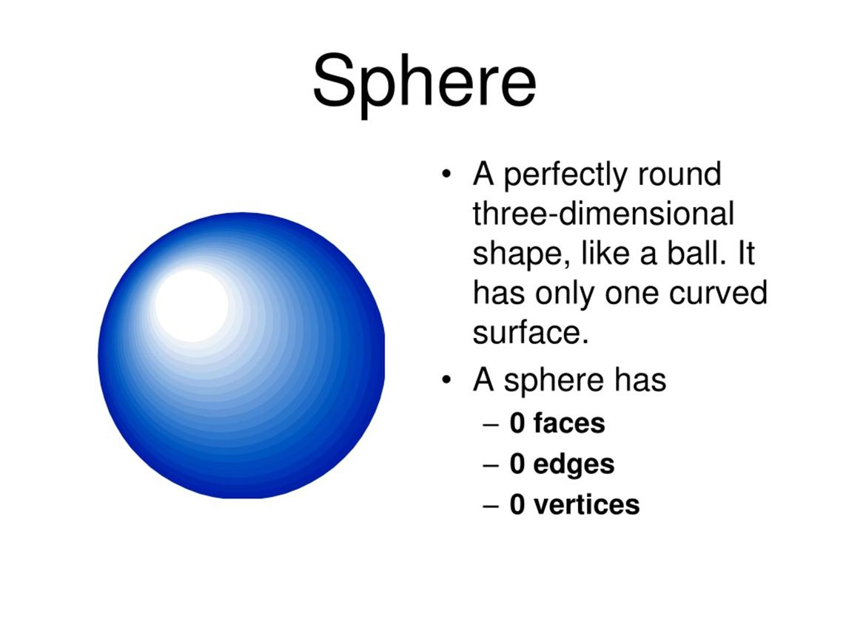
- Vertices: 0
- A sphere has a smooth surface and no corners or edges.

Number of Vertices in Common Solids
# Source: AI Source: Provided by: [Data Path: Persons Table -> ID Column: 1, Name_En Column: Motasem Essam] -> From: [ChatGPT] on [7/25/2026]
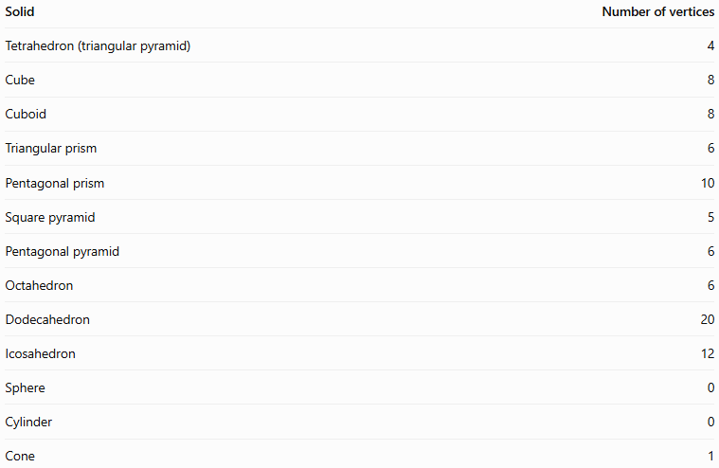
Solid | Number of vertices
Tetrahedron (triangular pyramid) | 4
Cube | 8
Cuboid | 8
Triangular prism | 6
Pentagonal prism | 10
Square pyramid | 5
Pentagonal pyramid | 6
Octahedron | 6
Dodecahedron | 20
Icosahedron | 12
Sphere | 0
Cylinder | 0
Cone | 1
Important distinction: A cone has one vertex, called its apex, while a cylinder has no vertices. Some curved solids have edges or boundary curves but no vertices.

Fundamental Properties

1 Vertices and Edges
# Source: AI Source: Provided by: [Data Path: Persons Table -> ID Column: 1, Name_En Column: Motasem Essam] -> From: [ChatGPT] on [7/25/2026]
An edge connects two vertices in a polyhedron.
For example, a cube has 8 vertices and 12 edges. Each edge joins a pair of vertices.

2 Vertices and Faces
# Source: AI Source: Provided by: [Data Path: Persons Table -> ID Column: 1, Name_En Column: Motasem Essam] -> From: [ChatGPT] on [7/25/2026]
A face is a flat polygonal surface of a polyhedron. Vertices occur at the corners of these faces.
For example, a cube has 6 square faces, and each face has 4 vertices. However, counting the vertices of all faces separately counts some vertices multiple times because adjacent faces share them.

3 Coordinates of a Vertex
# Source: AI Source: Provided by: [Data Path: Persons Table -> ID Column: 1, Name_En Column: Motasem Essam] -> From: [ChatGPT] on [7/25/2026]
In three-dimensional Cartesian coordinates, a vertex can be represented as
$$P=\left(x,y,z\right)$$
For a cube of side length $a$, one possible set of vertices is
$$\begin{aligned}&\left(0,0,0\right), \left(a,0,0\right), \\ &\left(a,a,0\right), \left(0,a,0\right), \\ &\left(0,0,a\right), \left(a,0,a\right), \\ &\left(a,a,a\right), \left(0,a,a\right).\end{aligned}$$
These coordinates describe all eight corners of the cube.

4 Euler's Formula
# Source: AI Source: Provided by: [Data Path: Persons Table -> ID Column: 1, Name_En Column: Motasem Essam] -> From: [ChatGPT] on [7/25/2026]
For a convex polyhedron, the number of vertices $V$, edges $E$, and faces $F$ satisfies
$$\boxed{V-E+F=2}$$
For a cube:
$$8-12+6=2$$
This relationship can help determine an unknown number of vertices, edges, or faces.

Types and Related Concepts
# Source: AI Source: Provided by: [Data Path: Persons Table -> ID Column: 1, Name_En Column: Motasem Essam] -> From: [ChatGPT] on [7/25/2026]
- Base vertex: A vertex belonging to the base of a solid, such as the base of a pyramid.
- Apex: The vertex opposite the base of a pyramid or cone.
- Polyhedral vertex: A corner where edges of a polyhedron meet.
- Adjacent vertices: Two vertices connected directly by an edge.
- Non-adjacent vertices: Two vertices that do not share an edge.
- Vertex coordinates: The ordered triple $\left(x,y,z\right)$ specifying a vertex's position in space.

Vertex vs. Edge vs. Face
# Source: AI Source: Provided by: [Data Path: Persons Table -> ID Column: 1, Name_En Column: Motasem Essam] -> From: [ChatGPT] on [7/25/2026]
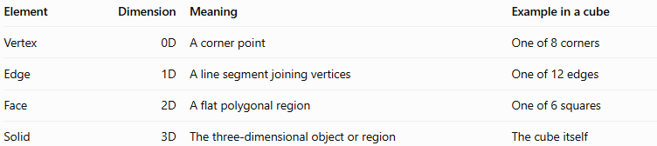
Element | Dimension | Meaning | Example in a cube
Vertex | 0D | A corner point | One of 8 corners
Edge | 1D | A line segment joining vertices | One of 12 edges
Face | 2D | A flat polygonal region | One of 6 squares
Solid | 3D | The three-dimensional object or region | The cube itself

Applications
# Source: AI Source: Provided by: [Data Path: Persons Table -> ID Column: 1, Name_En Column: Motasem Essam] -> From: [ChatGPT] on [7/25/2026]
Vertices are useful in:
- Geometry: Describing and classifying polyhedra.
- Architecture: Identifying corners and junctions in building models.
- Computer graphics: Defining the shape of 3D objects using vertex coordinates.
- Engineering: Constructing geometric models and analyzing connections.
- Mathematics: Applying Euler's formula and solving problems involving polyhedra.
- 3D modeling: Building meshes from vertices, edges, and faces.

Key Points
# Source: AI Source: Provided by: [Data Path: Persons Table -> ID Column: 1, Name_En Column: Motasem Essam] -> From: [ChatGPT] on [7/25/2026]
- A vertex is a corner point of a solid.
- The plural of vertex is vertices.
- Vertices are zero-dimensional.
- In polyhedra, edges meet at vertices and faces meet around them.
- A cube has 8 vertices; a triangular prism has 6.
- A cone has one vertex, while a sphere and cylinder have none.
- Euler's formula relates vertices, edges, and faces for convex polyhedra.

Conclusion
# Source: AI Source: Provided by: [Data Path: Persons Table -> ID Column: 1, Name_En Column: Motasem Essam] -> From: [ChatGPT] on [7/25/2026]
A vertex in Solid Geometry is a fundamental geometric element that identifies a corner of a solid. Together with edges and faces, vertices define the structure of polyhedra and help describe their shapes mathematically. Understanding vertices is essential for counting the elements of solids, studying their properties, representing them with coordinates, and constructing three-dimensional models.

